Royal’s Ordains

**Medieval fantasy side-scrolling beat’em up**

A concept of history meet modernity

# Game Idea and competitors

Royal’s Ordains is a side-scrolling action (Beat 'em up) game with RPG and historical education elements. The game setting is based on the Medieval period but mixed with a high fantasy setting to captivate a wider audience. The art style of the game aims to imitate the art style of Illuminated manuscripts from the Medieval period. This concept of adapting/incorporating traditional art style (Medieval manuscript art in particular) for video games is something that has rarely been done before.

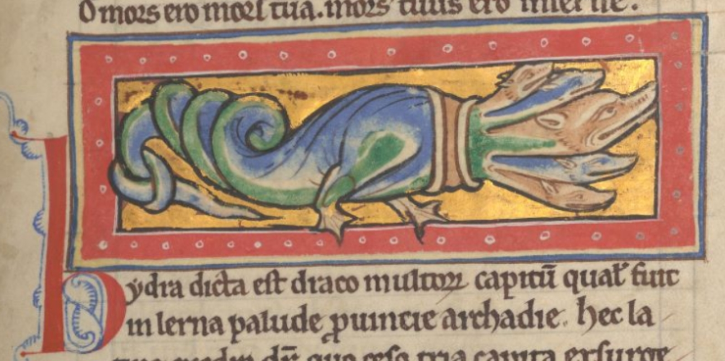

**Figure 1:** A hydra from *The Worksop Bestiary MS M.81*

This concept of Medieval art style adaptation, however, recently saw a small beginning in adaptation for historical games such as Pentiment (story-driven RPG game by Obsidian studio) and Inkulinati (Turn-based strategy game by Yaza Games). However, both of the examples are in a different genre from this project, and there have been no games of a similar genre as this project attempt to accomplish this feat. Hence, there would be no direct competitor in the market.

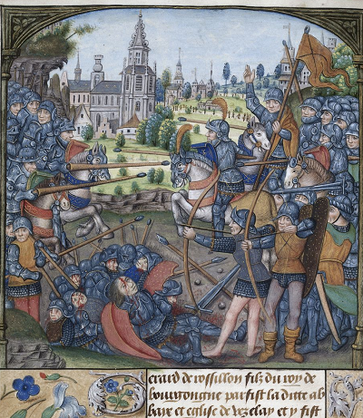

**Figure 2:** A battle scene from *Detailed record for Yates Thompson 32*

In terms of gameplay, the 2D side-scrolling beat 'em up is one of the most popular genres for the action game market, especially in indie game development. The most recent and closest competitors/comparisons to this game would be Tails of Iron1, Salt and Sanctuary2, and Blasphemous3. For the game to differentiate from the current game market, in addition to the unique art style, the game will focus on the gameplay of combat mechanics and keep the level of platforming to a minimum. The game will be in true two dimensions in terms of movement, unlike many other beat’em up genre games where players can move up and down on the stage.

# Game Overview

## Main Objective

* To let the player learn about medieval history, illuminated manuscript art making, whilst also having fun with a simple to learn but highly engaging gameplay.
* Provides a challenge to player with varied difficulty level that test their skill

## **Genre**

* Action/Beat’em up
* 2D
* Medieval Fantasy
* Single Player
* RPG
* Multiplayer (Co-Op and optional PVP)

## **Control**

**AD = Move right and left**

**S = Couch**

**W = Jump**

**J = Weak Attack**

**K = Strong Attack**

**L = Block**

**I = Special Move**

**U = Item**

**O = Emote**

**ESC = Pause game/ Learning mode**

Royal’s Ordains is a side-scrolling action game where a player takes control of one character who at the request/employment from the “King of Masendor” (Vars) to save the kingdom from various threats throughout the decades. The game’s gameplay and graphic are in 2 dimensions with art style similar to that of Medieval Manuscript. The game’s mood and graphic will be brutal and gory most of the time, especially in combat. The character animation will be vector based and each body part will have its own hitbox to calculate the most accurate sprite collide detection. The game allows upto 4 maximum players per session, with control of either a keyboard and/or joysticks. The number of monsters on screen/stage should be at the maximum of 100 at a time. The game will be designed for Personal Computer Operating Systems (Windows, MacOS, and Linux) in its first release, and potentially console or mobile later.

The art style will be similar to that of medieval manuscript which is linked to the story of the king employing a chronicler to record the hero activities and their deeds in real-time as a reward for embarking such glorious quest (idea a bit similar to pentiment). There will be also a narrator to narrate the story (in a manner similar to a fairy tale). The game also explore the concept of what would the people in medieval fantasy would record the story in manuscript, considering that monsters and legends are the reality overthere.

Figure 1: *Multi-layer generation images to create a battle map (Battle of Hastings in this example). The game uses a specific set of RGB colour values in the image data to create a combination of terrain types (e.g., water terrain + forest = swamp). The images can be easily created with graphic editor programs like Windows Paint or Adobe Photoshop. Note that the red/blue dots in the Final image represent a leader unit in battle.*

*The game will consist of 12 playable characters, which have diverse play-style. The player then controls the character to fight in a chapter-based mission against various types of foes, from bandits to monsters. Each character has different strengths, attacks, combos, and special abilities.*

The game provides a challenge to the player with a list of pre-set chapter missions. When player start the game from scratch, they can create a save slot and select one of the 12 available characters, which start from level 1. Player can level up their character each time they complete a mission, each level give a stat and skill points that player can allocate to improve the character and unlock new skills/combos.

During the mission, the game can trigger multiple random encounter/stage/weather that can positively or negatively affect players in some way. For example, a dragon may flyby and breath fire to a specific section of screen capable of damaging both players and enemies alike. Another example is a travelling merchant setting up shop for player during the mission.

The gameplay consist of two states for player: town area for player to learn about the game story/lore, purchasing/selling items, train, take side quests, selecting already played mission, or starting a new chapter. After selecting a mission, the player character will move to the first stage of the first mission of the selected chapter. Then they will attempt to accomplish the stage’s main objectives to win and able move to the next stage (or they can choose to return to town after). Each chapter will have multiple stages, and each stage may introduce new mechanic and monsters or new combinations of both. Each finished chapter will progress the game time and unlock a new look for the character.

The story will start with a somewhat cliche beginning of most fantasy story, a king ask a group of hero to fight against the multiple threats to his kingdom. Although the kingdom does provide (a meagre) funding and equipment for the group at first, they will be rewarded greatly if they can eradicate the threat (at the end of the chapter). The story will later become more complex and the cliche trope story will be more than what it seems.

The player can also create a customised challenge by using the custom battle mode to set up their own battle scenario which increase the game’s replayability. Each battle can have more than one scenario which can affect which character will appear in the battle, how many troops, army composition, weather, battle event, and even the faction involved.

In addition to the fun value that the game can provide to players, the game also provides good detail of historical information for most of the elements involved in the re-enaction of the battle. The game will include an in-game encyclopaedia with a description of the game mechanism, leader, troop and so on. For examples, the stamina mechanic section will describe why and how morale plays a part in battle with historical examples.

Figure 2: *In-game encyclopaedia for the leader character section.*

During the battle, a player can also open an "event log" interface that displays historical information about the events that occur during the playing battle and each scenario may present the information differently in tone based on the selected source of historical information. Here is the Battle of Hastings examples at 11:00.

* A Scenario based on the Chronicle by William of Poitiers, a Norman monk.  
  “Even William of Poitiers seems to accept that the English shield wall allowed them to withstand the charges. Although not as so impregnable that arrows and bolts could not deal death en masse.”
* A Scenario based on Chronicles by Saxons.  
  “The shield wall was almost impregnable to both infantry and cavalry alike as William's troops could not gain an advantage in this battle of attrition.”

The very heart of Masendor that makes it different from other games will be its accessibility and ease of creation for both players and ‘modders’ to expand the game further than the original scope. The game will provide tools and tutorials for content creation both inside and outside the game so that even players with little-to-no game modding experience can modify the game.

All the game data is kept in a module-based system. The game will have a system to detect available modules in the game data folder and let players select the module they want to use. The data is also stored in Comma-separated values (CSV) file format, which can be easily accessed and modified using a spreadsheet or database management software such as Microsoft Excel.

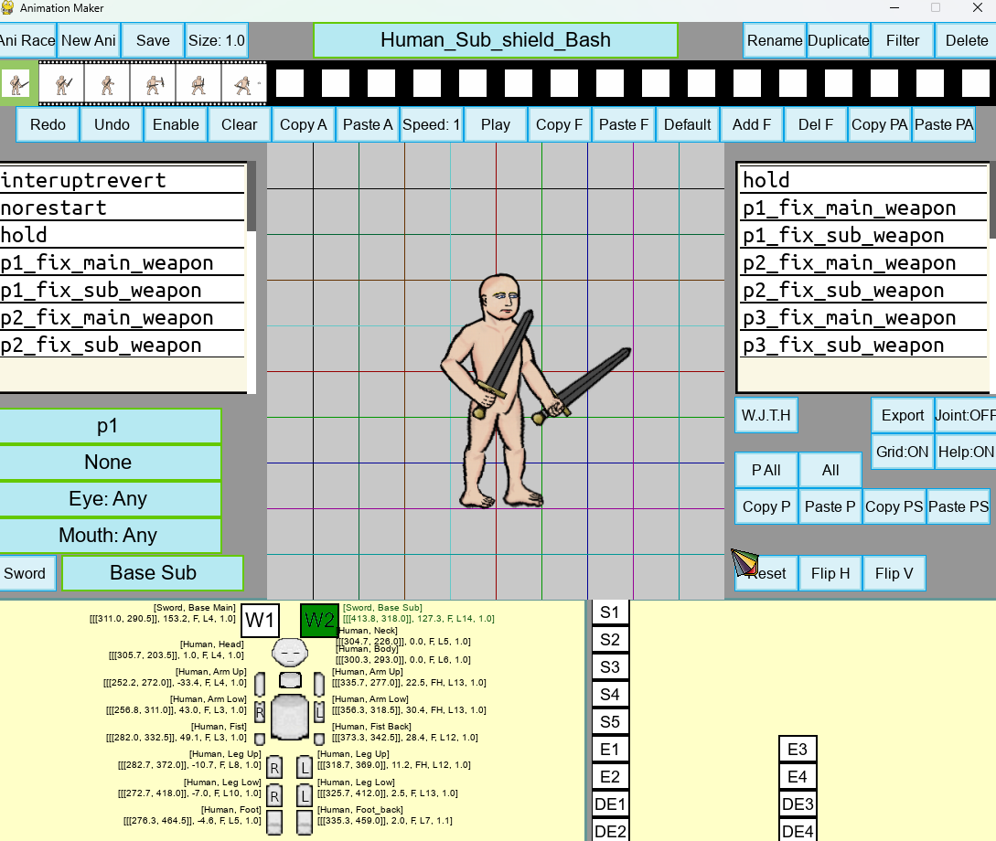

Figure 3: *Custom-made animation maker/editor for unit provided along with the game.*

All the game data is kept in a module-based system. The game will have a system to detect available modules in the game data folder and let players select the module they want to use. The data is also stored in Comma-Separated Values (CSV) file format, which can be easily accessed and modified using a spreadsheet or database management software such as Microsoft Excel.

# Summary Key Mechanic

- Simple to learn but difficult to master combat skill/combo

- Diverse cast of characters with unique gameplay mechanics

- Skill level up that is not simply damage number increase

- Random encounter and dynamic weather that affect players and enemies

- Equipment crafting system

# **Story**

The game story starts with a prologue with simple and common tropes of many medieval fantasy genre stories. A hero on a glorious quest to defeat monsters and a dragon to save a kingdom. This prologue serves as the first/tutorial mission of the game that introduces various gameplay mechanics to the player. The player cannot fail this mission, as the hero will simply replenish his health right away each time he falls to the enemy's attacks.   
  
Once the player completes this mission by killing a dragon, the main campaign will start, and the player can select a new hero from a list of 12 available characters. Again, the game's main story begins with the common tropes of a fantasy story, the King hires a group of heroes (the players) with a "Quest" to protect the kingdom against various threats in a series of chapters, from bandits, war, undead, and fantasy creatures. As the story progresses, players will learn more about the history of the character they are playing, the world itself, and the truth behind the "Quest".

# Development Plan

The game is developed in pure Python language using the Pygame library as its game engine for graphic, sound, and input systems. The game will use and adapt code and assets from the historical battle game for its foundation. A development demo should be ready after 1 year of development with the prologue mission and some missions from chapter 1 being playable.

There will be a total of 12 player characters making up from 6 classes, 1 male and 1 female for each class. The character class signify the character play style, for example, a warrior class character is more focused on melee combat with superior defensive skill like parry and block while archer class character is focused on ranged combat.

For the planned first full release (Version 1.0), the game will have 3 pre-set campaigns featuring 4 Battles involving the Ancient Egypt New Kingdom era, 7 battles involving the rise of English Norman and 6 battles involving the Ottoman Empire. Accordingly, the game will feature historical troops of the factions involved such as Norman Conroi, Huscarl, Ottoman Janissary, Sea People Raider, Egyptian Chariot, and many more. Each leader and troop will have different strengths, weaknesses, sets of equipment, skills, and traits. The custom battle mode will have 20 custom maps and a function to create a random-generated map in-game.

**Figure 4**: *Screenshot of battle in-game in snowing weather at the current development stage. The unit with orange circle background is a leader while the ones with grey circle is a troop.*  
  
Currently, the game is developed and published as an open-source game, while there are some minor helps in development from external parties, most of the tasks are still currently handled by internal development. Within the next month from now (July 2023), the game development will focus mainly on making the Battle of Hastings playable with the Medieval art style as a demo release in Early August with marketing on online social media and forum websites to gauge public interest with adequate balancing and bug testing.

If the demo manages to attract enough interest from the public (more than 10,000 total downloads for the demo release), the development of the game will be considered the main priority and the development of the game for the first release version will take place in 2 year. The internal development for the rest of the game can mainly be accomplished by 1 person with minor helps from external parties. With various royalty-free assets available on the internet for music/sound systems, the open-source nature of the game that may attract more volunteer helps after demo attraction, and assuming that the internal development team is made up of only 1 person, the development cost of 1 year should be around 20,000 £ or around 1,600 £ per month.

# 

## Character Stat

1. Each character start with a specific set of stat they specialise in. For example, warrior class character start with higher Strength, Dexterity, and Constitution, while mage character starts with higher Intelligence. Most of their attacks and skills performance will also be based on those stats most of the time. All stat can be used to unlock choice for story and quests, especially charisma.
2. Strength + Min physical attack, item number carry and slot (max stat should make max attack can deal double damage of based attack)
3. Dexterity + Max physical attack, critical, skill cast speed (max stat should make min attack always deal base damage)
4. Agility + animation speed, dodge (max stat should double animation speed from base)
5. Constitution + hp, block, knock resistant
6. Intelligence + Max non-physical attack, magic cast, mana resource (same as strength damage)
7. Wisdom + Min non-physical attack, everything a bit (same as dex damage)
8. Charisma + price improve, quest unlock, quest option unlock, improve companion stat

Each char at lv 1 start with some stat already pre-defined, player can reassign them at will. Level 1 give 100 points to assign. Then each lv up give 30 points

Stat 1-10 cost 1 stat point to increase, then increase by 1 every 10 points, stat max at 100 for player char.

|  |  |  |  |  |  |  |  |  |
| --- | --- | --- | --- | --- | --- | --- | --- | --- |
| **Char** | STR | DEX | AGI | CONS | INT | WIS | CHR | **Total** |
| Vars |  |  |  |  |  |  |  |  |
| Vraesier | 16 | 15 | 10 |  |  |  |  | **41** |
| Orsanoas | 24 | 8 | 12 |  |  |  |  | **44** |
| Minara |  |  |  |  |  |  |  | **0** |
| Rodhinbar |  |  |  |  |  |  |  | **0** |
| Omshle |  |  |  |  |  |  |  | **0** |
| Iri Kada Whe |  |  |  |  |  |  |  | **0** |
| Elmaliern | 4 |  |  |  |  |  |  | **4** |
| Nawgelo | 1 | 10 | 9 | 12 | 20 | 13 | 10 | **75** |
| Dragon Cleric |  |  |  |  |  |  |  | **0** |
| Duskuks |  |  |  |  |  |  |  | **0** |
| Nayedien |  |  |  |  |  |  |  | **0** |
| Soheh |  |  |  |  |  |  |  | **0** |
| **Total** | **45** | **33** | **31** | **12** | **20** | **13** | **10** | **0** |

## Character Skill

1. There are 2 types of skill in this game, common skills that all characters can use and specific character skill. Skills can be unlocked and improved when player level up. Characters also start with some skills already unlocked. All skill max lv at 5.
2. **Common Skill**

* Ground movement,

1. slide attack move (can knockdown), press weak attack when run
2. tackle move (can knockback), press strong attack when run
3. backward jump back, double press back move
4. weight no longer affect move speed
5. unlock dodge move during running (i-frame during animation) press defend when run

* Air movement,

1. can double jump
2. jump forward dash
3. half weight effect on jump
4. higher knock resistant in air
5. unlock triple jump

* Tinkerer skill

1. start with free items
2. 35% chance to not consume item when use
3. food increase more stat
4. unlock new item effect
5. unlock summon random item skills.

* arm master

1. unlock combo for pick-up weapon
2. increase more usage
3. i-frame during pick-up weapon attack
4. unlock weapon unique power
5. unlock summon random weapon skills.

* Wealth

1. coin also increase score
2. coin also increase resource (mana, arrow)
3. all enemy killed by user drop coins or items (before only limited random one can)
4. robbing failure now can be forgiven with gold payment
5. unlock lord of money skill (use money to deal damage to inflict charm to all enemies on screen)

* Immunity

1. knockback and knockdown can be cancel with jump to quickly standing up
2. shorten cc duration by half
3. when die rescue team come to resurrect once for free
4. Immune to weather effect
5. unlock immune barrier that block damage once every 10 seconds

* Resourceful

1. automatically regen resource
2. hitting enemy now also increase resource
3. blocking and crashing increase resource
4. increase resource generation, double resource cap
5. Unlock control fate, complete replenish source, cooldown 30 secs

* Combat contest

1. increase max block
2. attack crashing buff agi
3. can crash with boss attack
4. can walk while blocking
5. attack crashing make the next attack deal 100% more damage

|  |  |  |  |  |  |  |  |  |  |
| --- | --- | --- | --- | --- | --- | --- | --- | --- | --- |
| **Char** | GMV | AMV | T | AM | W | IMM | RS | CC | **Total** |
| Vars | 2 | 2 |  |  |  | 1 |  | 1 |  |
| Vraesier | 1 |  |  | 1 |  |  |  |  | **2** |
| Orsanoas |  |  |  |  |  | 1 |  | 1 | **2** |
| Minara |  |  | 1 |  |  |  | 1 |  | **2** |
| Rodhinbar |  | 1 |  |  |  |  | 1 |  | **2** |
| Omshle | 1 |  |  |  | 1 |  |  |  | **2** |
| Iri Kada Whe |  | 1 | 1 |  |  |  |  |  | **2** |
| Elmaliern |  |  |  |  |  | 1 | 1 |  | **2** |
| Nawgelo |  | 1 |  |  | 1 |  |  |  | **2** |
| Dragon Cleric | 1 |  |  |  |  | 1 |  |  | **2** |
| Duskuksa |  |  | 1 |  |  |  |  | 1 | **2** |
| Nayedien |  |  |  | 1 |  |  |  | 1 | **2** |
| Soheh |  |  |  | 1 | 1 |  |  |  | **2** |
| **Total** | **3** | **3** | **3** | **3** | **3** | **3** | **3** | **3** | **0** |

**Character specific skill**

All skills are active skill that require specific command input to use. Level 1 unlock the skill.

# Character List

Prologue/demo

Vars, human male

Play style: Close melee, medium speed

Weapon: sword, heater shield

Special ability:

**Couch:**

Weak: Shield punch, jab, pummel punch

Strong: Sword jab, sword slash out, then slash down

**Ground:**

Weak: Shield punch, shield semi bash up, sword pierce

Strong: Sword slash 3 times

Combo:

1 weak + strong = downward sword slash that can knockdown enemy

2 weak + strong = upward slash that can lift normal weight enemy

3 weak + strong = all direction spin slash

Special: Determination, activate when hp reach 0, no cooldown, increase all stats, defence, heal full hp, last 30 secs

**Air:**

Weak: sword slash,

Strong: shield bash

Down Strong: diving sword pierce

Skill:

1. Triple Slash (increase crit chance)
2. Endure (no stagger, immune debuff)
3. Great Offensive (7 fast melee attacks, can stun enemy, bleed)

## Warrior Characters

**Vraesier**, human female

Class: Demon Warrior

Path: Demoness (Special no longer require activation, blood no longer decrease overtime, special move use more blood but has larger aoe effect)/ Justiciar (Special move no longer use blood, blood decrease slightly slower than before)

Age: 19

Play style: Close melee, slow to medium speed, bleeding

Weapon: Longsword, Greatsword

Special ability: Demonic blood, gain special resource (blood) from enemy damage to unlock demon state to use greatsword for powerful attack, nearby bleeding dot also increase blood resource

**Normal Attack:**

**Couch:**

Weak: ground kick, kick up, rotate slash

Strong: Sword lower slash out, slash in, punch

**Ground:**

Weak: punch, Sword small slash, quick jab

Strong: Sword large slash,

Combo:

1 weak + strong = upper sword slash that can lift light weighted enemy

2 weak + strong = fast slash that inflict minor bleeding

3 weak + strong = all direction spin slash

Special: Greatsword swing, great sword downward slash, greatsword upward slash (can lift normal weight enemy up)

**Air:**

Weak: down kick, front kick, left down right slash

Strong: full arc slash

Special: Greatsword swing, great sword downward slash, greatsword upward slash (can lift normal weight enemy up)

**Skill:**

1. Double Slash (fast 2 hits attack)
2. Parry, counter attack (1 hit), counter cross slash (2 hits), also gain blood when parry,
3. Vital Piercing (bleeding dot), add slow debuff,
4. Second Wind (recover 20% hp 15 secs cd), also add 2% hp regen for over 10 secs, remove all debuff,
5. Eclipse Slash (greatsword)
6. Brutal blow (greatsword, hold to charge attack power), full charge also unleash a wave in both direction

**Demoness:**

1. Beheading (greatsword 100% crit chance)
2. Blood Drain (grapple if possible, drain enemy hp and give blood resource), also regenerate hp, also drain nearby enemies
3. Fatal Blood,
4. Blood Flood (summon wave of blood from left to right, cover whole screen),
5. Demonic Sight (all enemy in screen get fear), enemy also get slow, enemy also get

**Justiciar:**

1. Pommel Smash (25% stun), add disorient effect, unlock 2nd move close slash
2. Onslaught
3. Great Cleave (special)
4. Justice above all (+all stat, dmg reduction, stun all enemy on screen),
5. Punishing crime (grappel if possible, headbutt, punch, knee, then jump back and slash), headbutt now deal stun, punch now deal disorient, knee now deal slow, slash now deal bleeding

**Orsanoas,** human male

Class: Berserker

Path: Wrath / Jovial (Ozna companion)

Age: 23

Play style: Very close to close melee, medium to fast speed, crash counter

Weapon: Knuckles, Greataxe

Special ability: Unleash, gain special resource (fury or joy) overtime. Used for special moves that depend on selected path.

### Skill:

1. Grapple
2. Super punch (knockback), if crash triple power, stun enemy
3. Spinning slash
4. Iron Wall (can not be stagger), also immune to all debuff,
5. Taunt, enemy reduce stat,
6. Chopping Crash (smash with handle first, if crash with attack then slash with very high power), completely immune to damage during animation,

**Wrath:**

1. Berserk (increase STR, AGI, CON, all skill increase stun power), berserk also taunt all enemy
2. Crushing Wave
3. Bone Reconstruction (Grab)
4. World breaker (deal damage to whole screen, stun and disorient all enemy on screen)
5. Brawling

**Jovial:**

1. Cheer (increase all nearby friend stat)
2. Tag team whirlwind
3. Pure World (+speed for all friend, immune damage)
4. Combo assault
5. Tag team beat up

## Archer Characters

**Minara,** dwarf female

Class: Depth Hunter

Path: Tradition / Innovation

Age: 48

Play style: Medium to long range, slow to medium speed

Weapon: Twin pistol crossbows, Heavy Crossbow (Arbalest)

### Skill:

1. Pinning shot (pistol crossbow, pin enemy in place)
2. Blunt bash (can stun),
3. Heavy bolt (heavy crossbow shot ignore enemy defence, penetrate enemies)
4. Combined arms (attack with pistol crossbows 2 times, heavy crossbow 1 time, throw fire bomb reload and shoot it, has super armour)
5. Ricochet shot (heavy crossbow shot ricochet different enemy 3 times)

**Tradition**

1. Harpoon shot
2. Bayonet

**Innovation**

1. Barrage
2. Serrated Bolt

**Rodhinbar**, human male

Class: Combat Archer

Path: Conflict / Peace

Age: 25

Play style: Close melee to medium range, medium speed

Weapon: Shortsword, Bow

Special ability: Arrow resource require to shoot, can use special arrow depending on path

### Skill:

1. Pinpoint shot
2. Charged shot
3. Arrow shower
4. Precision slash
5. Retreating Shot
6. Rapid Acceleration (increase attack speed)

**Conflict:**

1. Explosive arrow, blind nearby (outside dmg aoe) enemy, knockback enemy, burn effect

**Peace:**

1. Imbue poison, add slow, add paralysis, poison can spread to nearby enemy

## Thief/Assassin Characters

**Omshle**, male moon town elf

Class: Assassin

Play style: Very Close melee to close range, fast speed

Weapon: Throwing dagger, dual daggers

Special ability:

### Skill:

1. Rising Moon (throw knife left up right 20 totals)
2. Into shadow
3. Blades of decay (dual daggers)

**Iri Kada Whe**, Hafling female

Class: Trapper

Play style: Close to medium range, medium speed

Weapon:

Special ability:

### Skill:

## Mage Characters

Elmaliern, human female

Class: Necromaner

Path: Love Eternal (binding strength+wisdom) / Grieving Friends (pact int+charisma)

Age: 29

Play style: Close melee to medium range, slow to medium speed

Weapon: Book

Special ability:

**Nawgelo,** sun high elf male

Class: Elemental wizard

Path: Infusion /

Age: 21

Play style: Close melee to medium range, very slow to slow speed

Weapon: Staff

Special ability:

## Support Characters

**female**

Class: Dragon Cleric

Path: Transcendent / Worship

Age:

Play style: Close melee to medium range, slow to medium speed

Weapon: Holy mace

Special ability: Faith

### Skill:

**Transcendent**

**Worship**

**Duskuksa**, male dwarf

Class: Rune sage

Path:

Age:

Play style: Close melee to close range, medium to fast speed

Weapon: A set of rune hammers

Special ability:

### Skill:

## Special Characters

**Nayedien Traitor of Elvenkind,** female sun wood elf

Class: Arcane warrior

Path:

Age: 188

Play style: Close melee to medium melee to long range, medium to fast speed

Weapon: 8 element summon weapons

Special ability: Stamina health, all attacks require stamina to perform unless stamina is at 0 then they use health instead.

### Skill:

**Soheh,** male halfling

Class: Veteran Mercenary (Landsneckt)

Path:

Special ability:

Age: 46

Play style: close melee, fast speed or medium melee, medium speed

Weapon: Halberd

Special ability: Stance swap, swap combo (something like score for different attack combo in dmc) higher score unlock new combo move

### Skill:

Slashing swap

## Missons

Prologue Vars (later king) origin, forest, wildlife, goblin, troll, boss black dragon

6 main chapters, each chapter happens a few years after the previous one:

1. Bandit = forest:

Mission 1: forest road stage human bandit Boss Adaqua (human)

Mission 2: rabbit tribe

Mission 3: wildlife and rabbit tribe Boss Armina (old elf)

Mission 4: human, dwarf, bandit camp mission Boss Mengkja (human)

Mission 5: human bandit citaldel mission Boss Pao La Sin (orge) and Mengkja

Western late medieval art style

World events: chronicler member attempt flying, Noise from heaven, sight of moving trees

6 months skip

1. War = field, village and fortress:

Mission 1: Boss Remance

Mission 2: Eona (Musician escort mission)

Mission 3: Boss Niavesia

Mission 4: Boss Gaf Ra Naf

Mission 5: Venvilov

Western renaissance art style

World events: tornado sight at, (human) bone fertiliser discovery, triple rainbow

special personal story mission for class branch

2 years 3 months skip

1. Orc and goblin = mountain,

Mission 1: steppe stage centaur

Mission 2: mountain stage harpy, goblin

Mission 3: cave stage troll, orc, goblin

Mission 4: cyclop

Mission 5: elite orc, war troll, goblin, Boss Vok

Aztec+ tribal art style

World events: Solar flare (Aurora in town sky), hell gate sighted near Masendor, Mounniley band visit Masendor (NPC group in town for lore)

1 year skip

1. Undead = wasteland: Boss Adupelel,

Western high medieval art style + spanish

World events: gunpowder discovery in northern dwarf kingdom, dancing plague, st.elmo fire tale

3 years skip

1. Assassin = civilisation, Boss Unsi Ed, Miyilya Cui An

Black hour book style

World events: breakthrough in astronomy, questioning heaven, mages population booming

6 months skip

1. Demon = hell, Boss

mixed Christian + Indian + Bhudist art style

World events: trouble at east side of continent, dragon priestesses bark like dogs and bite people for days, comet

(Maybe) special personal story ending mission

Bonus boss missions after story

1. Little Boy and Little Girl, run + dodge game

Kid fairy tale art

1. Hona vs Bahmarn and Feydiavy, 3 teams free for all
2. Sonagsha

Fairy tale manuscript style

1. Aunnial

Middle East + Buddhist + Christian

1. Vars

## Difficulty level

Difficulty affect enemy health, damage, attack speed/cooldown, enemy aggressiveness/randomness

1. Normal
2. Challenging
3. Macabre (Also add blood and gore)

## Important NPC

### Town Masendor:

Player can buy/sell item for golds, they can also attempt to rob by threaten store seller (and church) for free item with strength and charisma stat.

1. King (Vars) Masendor king that give out story questioning
2. Vurus as king’s advisor and military commander
3. Amunsa as blacksmith that craft and upgrade gear
4. Duhon as bar owner sell food and give bounty/side quest?
5. Sasinola as potion seller sell potion and material, give material collection side quest
6. Lisha as Magic shop seller sell spell scroll, accessory, talisman
7. Monnirl Maaeir as Church nun for healing/resurrect? sell holy item
8. Da Kedeus as gambling den master?
9. Musical band

### Party NPC:

1. Olsilin as Fairy carrying speaker (play music during battle)
2. Chronicler team
3. Rescue team (6 people)

## Random event / NPC (can occur in any stage except boss):

### Rare event:

1. Kidnapper
2. Toosiavi Beggar
3. Devil contact
4. Bounty hunter attack (become more severe each time win against them)
5. Flying hand attack
6. Filia thief (pay money to rob random store)
7. Oanogoht and Vellese Archaeologist digging mini game
8. Rock paper scissor game
10. Lamorkul Red Dragon fire
11. Unsi Ed assassinate someone or monsters on screen
13. Surprise boss, killer bunny, vampire,
14. Champion duel event (lose not mean end mission), every player regain hp to full after event
15. Shedna Dryad request
16. Fairy trick
17. Rescue team rescue
18. Wandering priest in background, buff and heal nearby players

### Common events:

1. Shrine buff
2. Travelling merchant
3. Goblin + Orc squads attack
4. Undead spawn
5. Demon teleport
6. Wildlife attack, wolf, bear, boar, eagle, bat,
7. Big chest/ mimic/ trap
8. Extra traps
9. Save villager from monsters
10. Resting Camp, can sleep to heal, cooking?, sleep + slime Item eater, random bandit ambush,
11. Alcohol maker (give random drink buff, drunk)
12. Mission Challenger (pay money, finish mission to get more money)
13. Investor
14. Random spell attack
15. Weather/ rain, snow, windy, (with different strength)

# Expansion?

Characters:

1. Dancer: Eona human female songstess, Chavu halfling male bard
2. Enchanter: Amunsa human male blacksmith,
3. Beastmaster
4. Jester?
5. Engineer
6. Puppet doll
7. Gremlin musketeer

Campaigns:

1. gremlin
2. high elf
3. dragon
4. magic empire
5. changing dungeon
6. giant northern mountain
7. doll factory

## Chronicle of

## Message

Text in bracket means marginalia.

### Defeat:

1. In the greatest show of bravery, the heroes rush back to town fearing that enemies will attack it after their defeat.
2. The enemies prove too much to bear. A tactical withdrawal is a necessary step for our quest from time to time. (why our king waste wealth to hire these people again?)
3. With the grace of God, the heroes safely return to the city, albeit not in triumph.
4. The illustration may show the heroes running in the opposite direction of the enemies. But this is simply the moment of an ingenious feign retreat! (or not)
5. Every journey has a return trip, although some are just a bit earlier than others.
6. The heroes claim that they heard a retreat signal from the king himself, or else they would never leave the battle midway like that. Their loyalty to the king is truly unequal.
7. This record is the stage of skirmishes that the heroes executed against the kingdom's greatest threats. The main combat and coup d'état parts are yet to come.
8. This is not a defeat for the heroes, only a momentary delay to the inevitable glorious victory.
9. Some people are good at fighting, and some are better at fleeing. It is likely that the hero may be too good at one of these.
10. No citizen in the fair city of Masendor blamed the heroes during their tattered return. Or at least we haven't really heard of such things from our Scriptorium.
11. Our finest rescue team get their wage paid once again. Hopefully, the treasury will still hold tight after all this is over.
12. A troubled day indeed that our foes become so strong. May the heroes return with vengeance in hands and valour in hearts.
13. Another day, another chance for the journey of the greatest heroes of Masendor. (I wonder how many pages this chronicle will be about the heroes' retreat.)
14. By the grace of our king and his brightest mind that the heroes will never fall into the wretch of enemies' hands. Death is not an option in this quest.
15. Through hell and high water, our children back home sigh in relief to still have the chance to hear the next tale of the heroes.
16. This failure resonates in every citizen's heart that the foes we faced are no doubt the crisis we will never be able to overcome just by ourselves. Glory be to the heroes and may God give them the strength to safeguard all that is good in the world.
17. Failure is often an important lesson and stop for success. Of course, if that lesson does not incur too much of the learner's life or the sponsor's wealth.
18. One may think the heroes take too much time to finish the quest, but patience is a necessary component that no generation of readers should ever forget.
19. The heroes of yore all faced failure before, and so do the heroes of nonce.
20. The heroes feared not death but failure in their quests and anguish in their beloveds' hearts. Now they march back to reprepare for triumph.
21. Only soulless celebrate our failure this day. All children of the lord God wept for a better day. Come next morn, the heroes will set things right.
22. Serene heart and calm mind, a failure is not the end. The greater sky possesses no limit, and so neither the rescue squad in vigilance.
23. The temple will be full of commitment for this day. Scapels will sink, dungs will drop, and healers will be here to help.